

**Guru Tegh Bahadur Institute Of Technology**

**2021**

ITP Practical File

Name: Harshpreet Singh

Class: CSE1(B)

Roll No: 04913202720

**INDEX**

|  |  |  |
| --- | --- | --- |
| **S.No** | **Name of Experiment** | **Remarks** |
| 3 | Write a recursive program for tower of Hanoi problem |  |
|  |  |  |
|  |  |  |
|  |  |  |
|  |  |  |
|  |  |  |
|  |  |  |
|  |  |  |
|  |  |  |

**EXPERIMENT-3**

**GITHUB LINK:**

**[Click Here](https://github.com/Harshpreet916/Harshpreet916/blob/4a49835f4260843865f4fc04fe6cf39bb4a6d00d/Factorial.c)**

**Pseudocode**

Let rod 1 = 'A', rod 2 = 'B', rod 3 = 'C'.

Step 1 : Shift first disk from 'A' to 'B'.

Step 2 : Shift second disk from 'A' to 'C'.

Step 3 : Shift first disk from 'B' to 'C'.

Pattern:

Shift 'n-1' disks from 'A' to 'B'.

Shift last disk from 'A' to 'C'.

Shift 'n-1' disks from 'B' to 'C'.

**Expected Input:**

**Any Number of user’s choice**

**Expected Output:**

A to B

             A to C

             B to C

            A to B

            C to A

            C to B

**Program:**

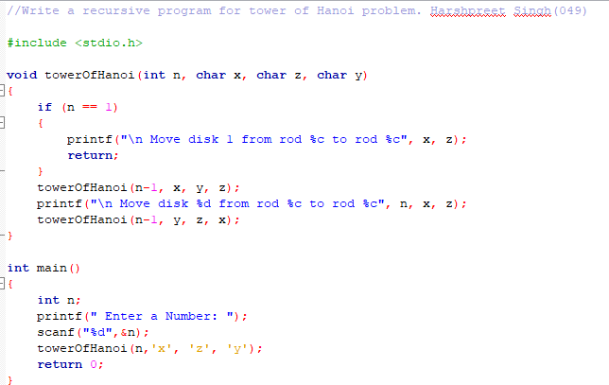

**Output**



